**OUTREACH SCHOOLS EXAMINATION BOARD**

**BEGINNING OF TERM III EXAMINATION 2023**

**TOP CLASS: (5 – 6 YEARS)**

**LEARNING AREA 5: LANGUAGE DEVELOPMENT II**

**My name is: ……………………………………………………………….**

**My School is: …………………………………….………………………..**

**I am in: ………………………………..…………………………….…………………..**

1. **Read and draw for the sounds.**

/oo/ broom spoon book

/ch/ chalk church bench

/ea/ beans leaf peas

/st/ stick stone stool

/oa/ goat coat boat

1. **Make sentences from these words.**

book: this is a book

pen: _______________________________

axe: ______________________________

duster: ______________________________

rag: _______________________________

pencil: _______________________________

1. **Form words.**

t

p b

s

1 tin

2 _______________

3 ________________

4 ___________________

5 __________________

1. **Match.**

a pot

p snake

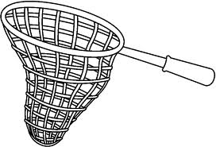

s net

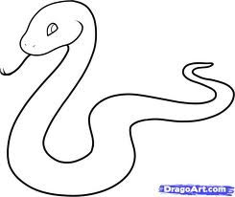

t tin

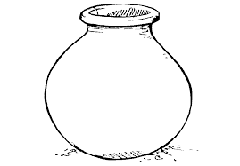

n apple

1. **Copy and write correctly.**

O o O o O o O o

____________________________________________________________________________________________________________________________________________________________________________________________________________

orange onion o’clock

____________________________________________________________________________________________________________________________________________________________________________________________________________

Orlando has an onion

____________________________________________________________________________________________________________________________________________________________________________________________________________

**End**